Chapter 1
INTRODUCTION

Cancer, a multifaceted adversary, claims millions of lives each year. Its early detection remains a pivotal challenge, often shrouded in the shadows of asymptomatic progression. However, a beacon of hope emerges from the realm of artificial intelligence: deep learning. This powerful technology, fueled by vast datasets and intricate algorithms, is rapidly transforming the landscape of medical diagnosis, and nowhere is its potential more profound than in the fight against cancer.

Deep learning's prowess lies in its ability to learn and adapt, mimicking the human brain's remarkable capacity for pattern recognition. With each exposure to medical images and data, its algorithms refine their understanding, discerning the subtle signatures of tumors amidst the complexities of human anatomy. This transformative power holds immense promise for multiple cancer types, each presenting unique challenges and opportunities for deep learning's application.

Lung cancer, a stealthy killer often diagnosed at late stages, manifests in chest X-rays and CT scans as intricate nodules and opacities. Deep learning algorithms trained on these images can identify these subtle abnormalities with remarkable accuracy, potentially leading to earlier diagnoses and improved survival rates.

Breast cancer, the most common cancer among women, presents in mammograms as suspicious masses and architectural distortions. Deep learning algorithms excel at pinpointing these irregularities, even in early stages, offering a powerful tool for proactive screening and intervention.

Bone cancer, often shrouded in diagnostic ambiguity, reveals itself in X-rays and CT scans as lytic lesions and fractures. Deep learning can navigate these complexities, differentiating malignant bone lesions from benign conditions, paving the way for more precise diagnoses and targeted treatment strategies.
This comparative analysis delves into the multifaceted world of deep learning-powered cancer detection, exploring its triumphs and tribulations across these three distinct cancer types. We dissect the specific deep learning architectures, training strategies, and challenges encountered in each domain, uncovering the unique opportunities and limitations presented by each cancer's distinct anatomy, imaging modalities, and disease presentation. Ultimately, we strive to paint a comprehensive picture of deep learning's potential to revolutionize cancer detection, illuminating the path towards a future where this insidious disease can be tackled with greater precision and efficacy.

By embarking on this comparative journey, we aim to not only showcase the remarkable progress made in deep learning-driven cancer detection but also identify the remaining hurdles and chart a course for future advancements. In doing so, we hope to empower researchers, clinicians, and ultimately, patients themselves, as we collectively strive towards a brighter future where cancer's grip on humanity is loosened, one pixel at a time.

OBJECTIVES

1. To comprehensively evaluate the current state of deep learning for detecting lung, breast, and bone cancers.
• Analyze the performance of various deep learning architectures and algorithms on each cancer type.
• Compare and contrast the effectiveness of different imaging modalities (e.g., CT scans, mammograms, X-rays) for each cancer.
• Identify the strengths and limitations of deep learning approaches in each context.

2. To investigate the unique challenges and opportunities associated with applying deep learning to each cancer.
• Explore the anatomical complexities and disease presentation specific to lung, breast, and bone cancers.
• Address the issue of data scarcity for each cancer type and propose potential solutions, such as transfer learning.
• Analyze the generalizability of deep learning models across different datasets and institutions.

3. To establish best practices and identify knowledge gaps in the field of deep learning-based cancer detection.
• Propose recommendations for developing more robust and clinically-relevant deep learning models for cancer diagnosis.
• Highlight areas requiring further research and development to advance the field.
• Foster collaboration and knowledge sharing among researchers and clinicians working on cancer detection using deep learning.

4. To pave the way for the development of clinically-implementable deep learning tools for early and accurate cancer diagnosis.
• Evaluate the potential impact of deep learning on improving patient outcomes across diverse cancer types.
• Explore the ethical considerations and regulatory pathways for integrating deep learning models into clinical practice.
• Contribute to the advancement of personalized medicine by enabling early detection and tailored treatment strategies.

5. To present a comprehensive comparative analysis that benefits researchers, clinicians, and the broader healthcare community.
• Provide a valuable resource for researchers working on deep learning for cancer detection.
• Offer insights and recommendations for clinicians interested in adopting deep learning technologies in their practice.
• Raise awareness about the potential of deep learning to improve cancer diagnosis and treatment for the general public.

6. To contribute to the ongoing fight against cancer by exploring and promoting innovative deep-learning approaches for early detection.
• Ultimately, the goal is to harness the power of deep learning to save lives and improve quality of life for cancer patients.
• By identifying promising avenues for research and development, this work can contribute to the development of more effective and accessible cancer detection tools.

  - SCOPE

• Explore the specific deep learning architectures and strategies employed for each cancer type.
• Analyze the strengths and limitations of these approaches, drawing insights from relevant datasets and benchmark studies.
• Address the challenges of data scarcity, transfer learning, and generalizability for each cancer, proposing potential solutions and future research directions.
• Through this comparative lens, we hope to illuminate the current landscape of deep learning- based cancer detection, identify best practices and knowledge gaps, and ultimately pave the way for more robust and clinically-relevant applications across diverse cancer contexts.

Chapter 2
PROBLEM STATEMENT

PROBLEM:

Despite significant advancements in medical technology, early and accurate diagnosis of diverse cancers, like lung, breast, and bone, remains a critical challenge. Traditional methods often suffer from limitations in sensitivity, specificity, and labor intensiveness. While deep learning holds immense potential for automated cancer detection, its successful application presents specific challenges when navigating the complexities of distinct cancer types.

SOLUTION:

Develop a unified deep learning framework tailored to different cancer types, enhancing sensitivity and specificity while reducing labor intensiveness. Integrate advanced imaging techniques and multi-modal data fusion to improve early and accurate diagnosis across lung, breast, and bone cancers.

Chapter 3
LITERATURE SURVEY

1. Efficient Ultra Wideband Radar Based Non-Invasive Early Breast Cancer Detection
• Author: A. S. M. Mohsin, et al.
• Publication Year: 2018
• Methodology: Using ultra-wide radar for early detection of breast cancer.
• Observation: It offers an efficient radar-based approach for early detection of breast cancer.
2. Deep Neural Networks Improve Radiologists’ Performance in Breast Cancer Screening
• Author: M. Rodriguez-Ruiz, et al.
• Publication Year: 2019
• Methodology: Implementation of Deep Neural Networks to Enhance Radiologist Performance in Breast Cancer Screening.
• Observation: Demonstrates improved screening outcomes when combining radiologists' expertise with deep neural networks.
3. Improving Cancer Detection Classification Performance Using GANs in Breast Cancer Data
• Author: L. A. Salehahmadi, et al.
• Publication Year: 2020
• Methodology: Adding an generative adversarial network (GAN) to improve the classification performance of breast cancer diagnosis.
• Observation: It shows the effectiveness of GAN in improving the classification accuracy of breast cancer data.
4. A Review on Recent Progress in Thermal Imaging and Deep Learning Approaches for Breast Cancer Detection
• Author: M. S. Eisa, et al.
• Publication Year: 2020
• Methodology: A comprehensive review summarizes recent advances in thermal imaging and deep learning for breast cancer diagnosis.
• Observation: Provides insight into advances and potential challenges in thermal imaging and deep learning in ovarian cancer diagnosis.
5. A CMOS-Based Capacitive Biosensor for Detection of a Breast Cancer MicroRNA Biomarker
• Author: M. Rezaee, et al.
• Publication Year: 2021
• Methodology: Development of a CMOS-based capacitive biosensor for detection of breast microRNA biomarkers.
• Observation: Introduces a biosensing approach for early detection of breast cancer-related biomolecules.
6. An Automatic Detection of Breast Cancer Diagnosis and Prognosis Based on Machine Learning Using Ensemble of Classifiers
• Author: A. V. Singh, et al.
• Publication Year: 2021
• Methodology: Application of machine learning techniques, specifically a set of classifiers, for automated breast cancer diagnosis and prognosis.
• Observation: Demonstrates the potential of ensemble methods in improving accuracy in breast cancer diagnosis and prognosis.

Chapter 4
PROJECT DESCRIPTION

4.1 PROPOSED DESIGN
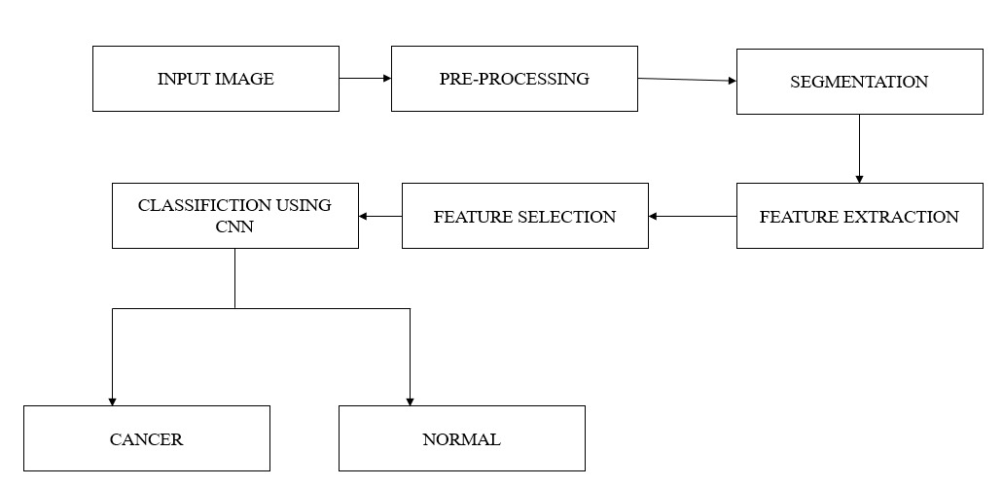
Figure 4.1.1 Cancer Detection level 1

Project Description:
Objective:
● Early Detection: Develop a machine learning system that enables the early detection of cancerous tumors in medical images.
● Accuracy: Achieve a high level of accuracy in cancer detection to improve diagnostic outcomes.
● Data Collection: Gather a comprehensive and diverse dataset of medical images along with accurate labels for model training and testing.
● Data Preprocessing: Implement data preprocessing techniques, including resizing, normalization, and augmentation, to ensure data quality and consistency.
● Model Development: Select and train appropriate machine learning models, such as convolutional neural networks (CNNs), to effectively classify cancerous and non-cancerous tumors.
● Performance Metrics: Evaluate model performance using metrics such as accuracy, precision, recall, F1-score, and ROC-AUC to ensure reliable results.
● Interpretability: Implement model explainability tools to provide insights into why specific predictions are made, aiding healthcare professionals' decision-making.
● User-Friendly Interface: Create an intuitive and accessible user interface, allowing healthcare providers to easily upload medical images for analysis.
● Data Security: Ensure robust data security measures to protect patient privacy and comply with data protection regulations.
● Compliance: Ensure compliance with relevant healthcare and data privacy regulations, including HIPAA or GDPR, to maintain ethical standards.
● Deployment: Deploy the system in healthcare settings, either on-premises or in the cloud, to make it readily available to medical professionals.
● Monitoring and Maintenance: Continuously monitor the system's performance and maintain it through regular updates and improvements.
● User Feedback: Establish a feedback mechanism to collect user feedback and utilize it to enhance the model and system.
● Collaboration: Foster collaboration between data scientists and healthcare experts to align the model with clinical needs and standards.
● Ethical Considerations: Develop guidelines and protocols for handling ethical dilemmas, ensuring responsible use of AI in healthcare.
● Documentation: Maintain comprehensive documentation of the project's progress, including model architecture and validation procedures.
● Disaster Recovery: Implement disaster recovery measures to ensure system availability in unforeseen circumstances.
● Cost Management: Manage resource usage and costs effectively throughout the project lifecycle.
● Regulatory Compliance Testing: Conduct rigorous testing to ensure compliance with healthcare regulations before clinical deployment.
Components:
a. Data Collection:
Gather a diverse dataset of medical images containing cancerous and non- cancerous cases.
b. Preprocessing:
Standardize image sizes, enhance contrast, and remove noise.
c. Feature Extraction:
Extract relevant features such as texture, shape, and intensity from the images.
d. Machine Learning:
Train and test various machine learning algorithms (e.g., CNNs, SVM, or decision trees) for classification.
e. Integration:
Develop a user-friendly interface for uploading images and obtaining analysis results.
f. Evaluation:
Assess the system's performance through cross-validation, ROC curves, and other relevant metrics.
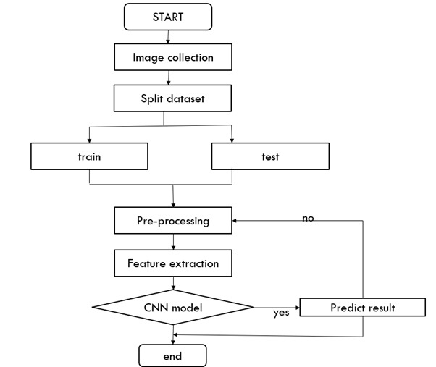
Figure 4.1.2 Cancer Detection level 2
Chapter 5
REQUIREMENTS

5.1 SOFTWARE REQUIREMENTS
• Operating system: Windows XP / Windows 10.
• Software Tool: IDLE (PYTHON 3)
• Coding Language: Python
5.1.1 Functional Requirements:
5.1.1.1 Preprocessing:
• Data import and cleansing: Support for importing and cleansing medical imaging data (CT scans, mammograms, X-rays) from various formats and sources.
• Image registration and segmentation: Align images across different modalities and segment relevant anatomical regions (lungs, breasts, bones) accurately.
• Data Augmentation: Implement techniques like image resizing, flipping, and rotation to artificially expand the training dataset.
5.1.1.2 Deep Learning Model Training:
• Support for multiple deep learning architectures: Train and compare different architectures suited for each cancer type (e.g., CNNs for lung nodules, RNNs for bone texture analysis).
• Modular training framework: Allow flexibility in swapping pre-trained
models, hyperparameter tuning, and training on specific datasets (lung, breast, bone).
• Loss function selection: Support for various loss functions tailored to each cancer detection task (e.g., binary cross-entropy for malignancy classification, focal loss for imbalanced datasets).
• Visualization tools: Provide tools for visual analysis of training curves, activation maps, and predicted regions of interest.
5.1.1.3 Model Evaluation and Comparison:
• Standard performance metrics: Calculate and display relevant metrics for each model (e.g., accuracy, sensitivity, specificity, AUC) for each cancer type.
• Statistical analysis: Support statistical tests to compare the performance of different models and datasets.
• Interpretability tools: Provide visualization and feature importance analysis to understand the decision-making process of the models.
5.1.1.4 User Interface and Output:
• Intuitive interface: Design a user-friendly interface for selecting models, datasets, and running comparisons.
• Interactive visualization: Display results in an interactive format, allowing users to explore images, predictions, and model performance comparisons.
• Report generation: Generate reports summarizing the analysis and comparisons, including performance metrics, visualizations, and key findings.

5.1.2 Non-Functional Requirements:
5.1.2.1 Performance:
• Fast training and inference: Efficient execution of deep learning models to ensure timely analysis and results.
• Scalability: Ability to handle large datasets and train complex models without significant performance degradation.
• Resource efficiency: Utilize computing resources efficiently while maintaining accuracy and performance.
5.1.2.2 Security and Privacy:
• Data security: Secure storage and transmission of sensitive medical data with appropriate encryption and access control.
• Privacy compliance: Adherence to relevant data privacy regulations and ethical guidelines.
5.1.2.3 Usability:
• User-friendly interface: Easy to navigate and understand for users with varying levels of technical expertise.
• Documentation and tutorials: Provide comprehensive documentation and tutorials for users to understand the system and its functionalities.
5.1.2.4 Maintainability and Extensibility:
• Modular design: Modular codebase for easy modification and extension of specific components (e.g., model training, evaluation, reporting).
• Version control and testing: Use version control systems and implement automated testing for code maintenance and stability.

5.2 HARDWARE REQUIREMENTS
• Processor: Intel Core i5Processor
• Speed: 2.6 GHz
• RAM: 4GB and above
• Disk space: 120 GB and above

Chapter 6
METHODOLOGY
6.1 HIGH LEVEL DESIGN
6.1.1 Data Acquisition and Preprocessing:
o Identify and gather relevant datasets for each cancer type (lung CT scans, breast mammograms, bone X-rays/MRIs).
o Preprocess data to address discrepancies and ensure comparability across cancer types (normalization, image enhancement, etc.).
6.1.2 Deep Learning Model Selection and Training:
o Compare and contrast different deep learning architectures suitable for each cancer type (e.g., CNNs for lung nodules, transfer learning for mammograms, autoencoders for bone lesions).
o Train separate models for each cancer type, optimizing hyperparameters based on specific dataset characteristics and performance metrics.
6.1.3 Comparative Analysis and Evaluation:
o Evaluate the relevant validation and test database using appropriate metrics (accuracy, sensitivity, specificity, etc.) of each model.
o Analyze and compare the models' strengths and weaknesses, focusing on factors like feature extraction, prediction accuracy, and generalizability.
6.1.4 Challenges and Future Directions:
o Discuss the challenges encountered in each cancer type, such as data scarcity, anatomical complexity, and inter-patient variability.
o Propose potential solutions and future research directions for improving deep learning-based cancer detection across all three cancer types.

6.2 SYSTEM ARCHITECTURE
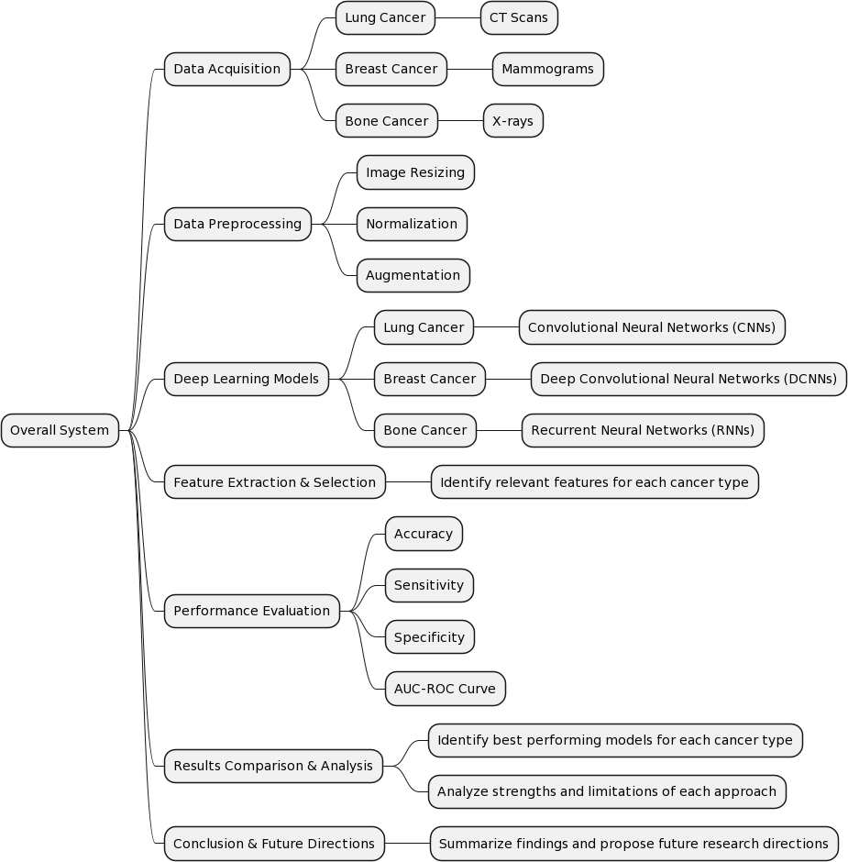
Figure 6.2.1 System Architecture

• Data Acquisition: This module gathers medical imaging data for each cancer type from relevant sources like public datasets, hospital repositories, or clinical trials. Data formats may include CT scans, X-rays, mammograms, and bone scans.
• Preprocessing: Each image undergoes preprocessing steps like noise reduction, normalization, and augmentation to improve training and model performance. Specific preprocessing techniques could vary depending on the image modality and cancer type.
• Feature Extraction: Deep learning models require relevant features from the images for cancer detection. This module utilizes specialized convolutional neural networks (CNNs) trained on each cancer type to extract distinctive features from the preprocessed images.
• Classification/Diagnosis: Extracted features are fed into separate classifiers for each cancer type. These classifiers, also deep learning models, analyze the features and output a diagnosis: either cancer or benign for each image.
• Evaluation and Comparison: Individual module outputs are then compared and analyzed across all cancer types. This stage assesses the performance of each deep learning model using metrics like accuracy, sensitivity, and specificity. Additionally, comparative studies are conducted to identify common trends and discrepancies in cancer detection across different cancers.
• Visualization and Interpretation: The system generates visually interpretable outputs like heat maps highlighting suspected cancerous regions in the images. This aids healthcare professionals in understanding the model's decision-making process and building trust in the system.
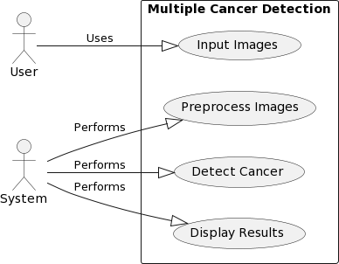
6.3 USE CASE DIAGRAM

Figure 6.3.1 Use Case Diagram

• User (U): Represents the user interacting with the system.
• System (S): Represents the system performing various tasks.
• Input Images: Use case where the user provides images for cancer detection.
• Preprocess Images: Use case where the system preprocesses the input images before cancer detection.
• Detect Cancer: Use case where the system employs deep learning techniques to detect cancer from preprocessed images.
• Display Results: Use case where the system displays the results of cancer detection to the user.

6.4 MODULE SPECIFICATION
Module specification is a method to improve structural design by dividing the system into modules and solving them as independent problems. This reduces complexity and allows modules to be tested independently.
Image pre-processing.
Histopathological images can be used as a training base or input images for target recognition. Images are captured and saved in any format supported by the device
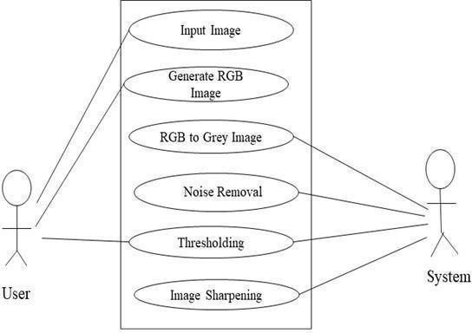
Name of the Module: Pre-Processing.
Figure 6.4.1 Use Case Diagram For Pre-Processing Module

• Actors: User, System.
• Use examples: input image, create RGB image, RGB grayscale, noise extraction, thresholding, disease detection, sharpening image.
• Functionality: The main functionality of this module is to preprocess the data for easy access.
• Description: Figure 6.4.1 shows the use case diagram of the pre-processing module. In this use case diagram, there are six use cases and two actors. In the first use case, an image is captured and used as input to this module. In the second use case, an RGB image is generated for the captured image. In a third use case, to reduce the complexity of an RGB image to a gray scale image. In the fourth use case noise is removed. In the fifth use case, thresholding is performed. In the sixth use case, image sharpening is carried out.
6.5 Segmentation
Segmentation is done to divide the image into two areas, the background and the area of interest. The shared image contains a fiber and background area with a pixel value of '0'. This image is then used as a mask to extract the egg region from the RGB image by multiplying the gray image. The scale of the image is changed to reduce the size of the matrix used for identification. The images are then transformed into a column matrix to extract features.
6.6 Feature Extraction
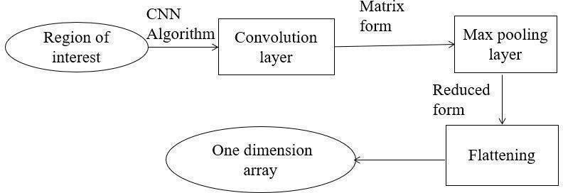
Feature extraction is the most important step in the recognition phase because the dimensionality of the data is reduced in this phase. This feature extraction model aims to convert the segmented image into a compact set of one-dimensional values that facilitate efficient and accurate representation of risk groups. The main purpose of this module is to apply component analysis and obtain statistical values.

Figure 6.6.1 Feature Extraction from Segmented Image.
6.7 Classification and Detection
• Actors: System, User
• Use Cases: Preprocessed Image, Training, Classification, Disease Recognition
• Function: The main function of this module is to detect cancer
• Description: Figure 6.7.1 shows the use case diagram of the classification module. In this use case diagram, there are four use cases and two actors. In the first use case, the system takes a preprocessed image. A second use case classifier is trained.
In the third use case classifier is applied. In the fourth use case the disease if present is recognized.
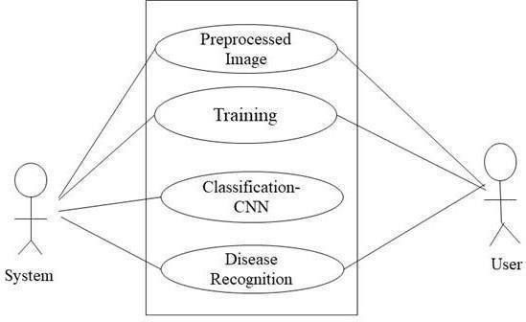
Figure 6.7.1 Use Case Diagram of Classification using CNN module

6.8 Data Flow Diagram

As the name specifies so to the meaning of the words, it is the process which is explained in detail like how the data flows between the different processes. The below figure 6.8.1 depicts the flow diagram and is composed of the input, process and the output. After each process the data which is flown between the systems need to be specified and hence called the data flow diagram. In most of the times it is the initial step for designing any of the systems to be implemented. It also shows from where the data originated, where the data flowed and where it got stored. The obtained RGB image is converted into grey scaled image to reduce complexity. The detected input ovarian image (histopathological image) is classified once after preprocessing, segmentation is done to extract the significant features which are then matched with images in dataset.

6.9 Data Flow Diagram of Pre-processing Module

As shown in the figure 6.9.1 initially the set of histopathological images are stored in a temporary file in OpenCV. The storage is linked to the file set account from which the data is accessed. The obtained RGB image is converted in to grey scale image to reduce complexity.
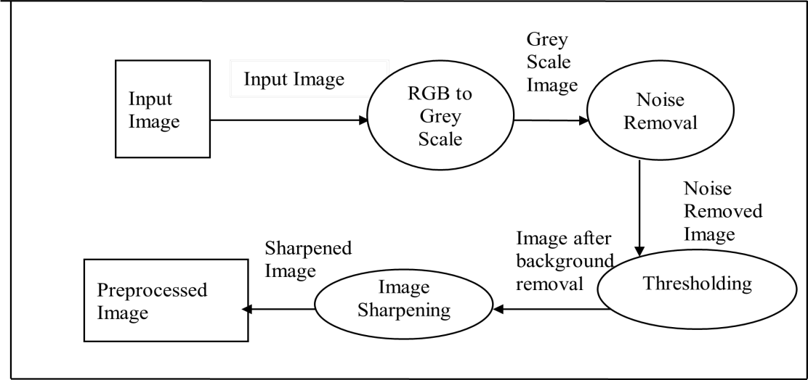
Figure 6.9.1 Data Flow Diagram for Pre-Processing Module.

Preprocessing is required on each image to maximize image efficiency processing. Captured images are in RGB format. The pixel values and dimensions of the captured images are very high. Since an image is a matrix, a mathematical operation on an image is a mathematical operation on a matrix. So we convert an RGB image to a grayscale image. Then we carry out Noise Removal followed by Thresholding, the last step is Image Sharpening after which we obtain the preprocessed Image.

Data Flow Diagram of Classification Module
The goal of the classification process is to divide all digital image pixels into one of several land cover classes or "themes". This classification data can be used to map the topic of land cover in the classification data flow diagram using CNN. In deep learning, convolutional neural networks (CNN or ConvNet) are a class of deep neural networks commonly used for visual image analysis. Also known as shift invariant or space invariant artificial neural networks (SIANN) based on general weight architecture and translation invariant properties. When CNN is used for classification, we don't need to perform feature extraction. Feature extraction will also be conducted by CNN. We feed the pre- processed image directly to a CNN classifier to obtain the disease type if present.
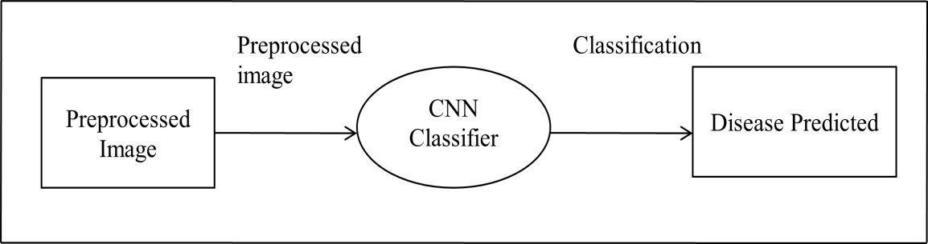
Figure 6.9.2 Data Flow Diagram of Classification using CNN.

State Chart Diagram

A state chart diagram is also named as state diagram. It is popular one among five UML diagrams and it is used to model the dynamic nature of the system. State chart defines various states of an object during its lifetime. The state chart diagram is a composition of finite number of states and the functionalities describe the functioning of each module in the system. It is a graph where each state is a directed edge and represented by node and these directed edges represents transition between states. The state chart diagram is depicting a CNN training process that starts with loading and data. The model then undergoes training, followed by evaluation on a separate dataset.

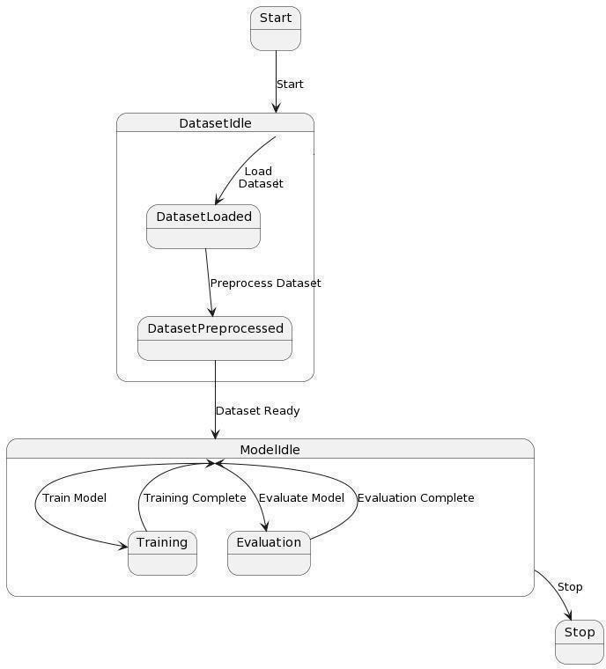

Figure 6.9.3 State Chart Diagram of Model using CNN.

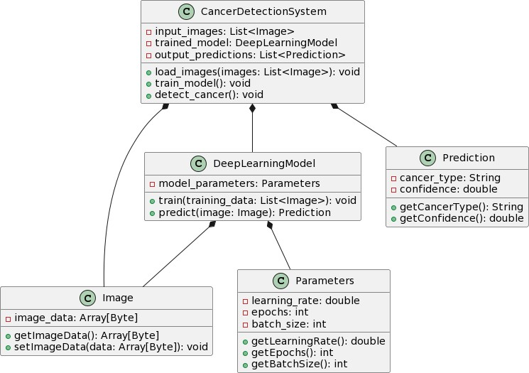
6.10 Class Diagram
Figure 6.10.1 Class Diagram

• Cancer Detection System: Represents the main class of the system, responsible for managing input images, training the deep learning model, and detecting cancer.
• Image: Represents an image input to the system. It contains image data represented as an array of bytes.
• Deep Learning Model: Represents the deep learning model used for cancer detection. It includes methods for training the model with input images and predicting cancer types.
• Prediction: Represents the output of the cancer detection process, including the predicted cancer type and confidence level.
• Parameters: Contains parameters used for training the deep learning model, such as learning rate, epochs, and batch size.

6.11.1 ACTIVITY DIGRAM
1. Data Source: Responsible for gathering data required for training deep learning models.
2. Deep Learning Model: Consists of various stages such as data preprocessing, model training, evaluation, and deployment.
• Data Preprocessing: Cleans and prepares the collected data for training.
• Model Training: Trains deep learning models using preprocessed data.
• Model Evaluation: Evaluates the trained model’s performance.
• Model Deployment: Deploys the trained model for real- world usage.
3. User Interface: Represents the interaction with the system, including providing input for the data source and displaying results after model deployment.

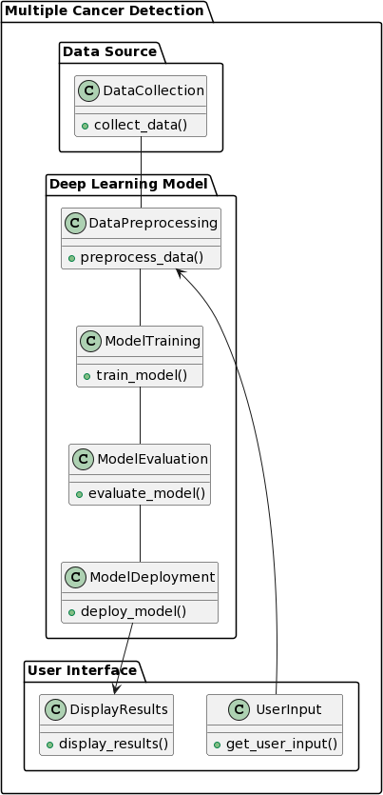

Figure 6.11.1 Activity Diagram

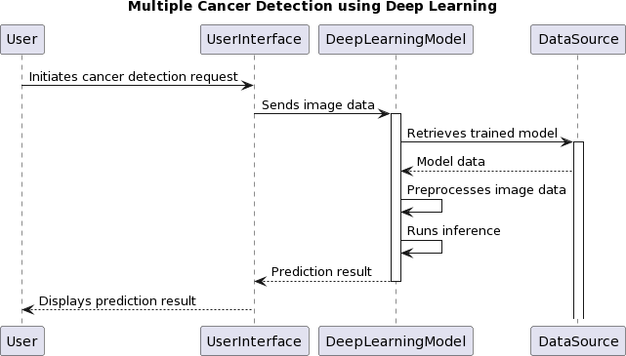
6.12 Sequence Diagram
Figure 6.12.1 Sequence Diagram
• User: Initiates the request for cancer detection.
• User Interface: Collects input data from the user and sends it to the deep learning model.
• Deep Learning Model: Receives the image data, retrieves the trained model from the data source, preprocesses the image data, runs inference, and sends the prediction result back to the user interface.
• Data Source: Provides the trained model to the deep learning model.

Chapter 7
EXPERIMENTATION
7.1 IMPLEMENTATION
Implementation is the transformation of a new system design into a practical design. Key steps in creating a successful new system. Therefore, it must be carefully planned and monitored. The system is implemented after the development effort is completed.
Steps for implementation
7.1.1 Front-End Development Using Python Flask:
Modern computer programs are user-friendly. User interaction is not limited to console-based I/O. It has a more ergonomic graphical user interface (GUI) thanks to the high-speed processor and powerful graphics hardware. The program is accessible by clicking the mouse and allows the user to select options using radio buttons, drop-down lists, and other GUI elements.
7.1.2 Flask Programming:
Flask is a standard GUI library for Python. When combined with Flask, Python provides a quick and easy way to build GUI applications. Flask provides a powerful object-oriented interface to the Tk GUI toolkit. Flask has a lot of power. It's cross-platform, so the same code runs on Windows, macOS, and Linux. Visual elements are represented by native operating system elements, so applications built with Flask look like the platform they're running on.
7.1.3 Implementation Issues:
The implementation phase of software development focuses on translating design specifications into source code. The main goal of the implementation is to write the source code and internal documentation so that the code can be easily checked against the specifications and debugging tests and modifications are facilitated. This goal can be achieved by making the source code as clear and straight forward as possible. Reliability Transparency and simplicity are the hallmarks of good software, and these features are implemented in every software module.
The purpose of this implementation is as follows:
• Reduce memory requirements.
• Improve the readability of the output.
• Improve the readability of the source text.
• Reduce the number of source sentences.
• Reduce development time
7.1.4 Module specification:
Module specification is a method to improve structural design by dividing the system into modules and solving them as independent problems. This reduces complexity and allows modules to be tested independently. The number of modules for our model is three, namely preprocessing, recognition, feature extraction, and detection. Therefore, each phase represents the functionality provided by the proposed system. In the data processing stage, the sound is extracted using a median filter.
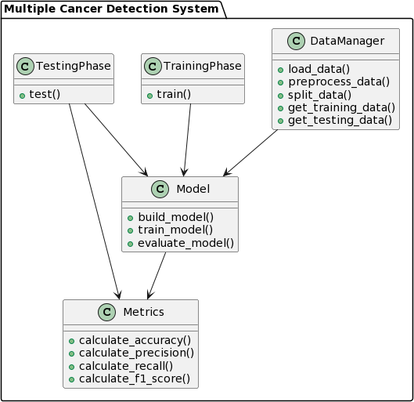
Figure 7.1.4.1 Module Specification
System design is fundamental
1. Photo collection
2. Image processing
3. Image segmentation
4. Extracting features
5. Learning
6. Classification

1. Image Collection:
The dataset we used in this project is publicly available on the internet.
2. Image Preprocessing:
The purpose of preprocessing is to enhance the image data that reduces unwanted distortions and enhances certain image features that are important for further image processing. Image preprocessing includes three main things
a) Grayscale conversion b) Eliminating noise c) image enhancement
a) Grayscale conversion: Grayscale images contain only luminance information. Each pixel value in gray corresponds to the number or amount of light. Emergency terminations can be distinguished in the grayscale image. Grayscale images only measure light intensity. An 8-bit image varies in brightness between 0 and 255, where '0' is black and '255' is white. Grayscale conversion displays color images as grayscale images. Grayscale images are easier and faster to process than color images. All image processing methods are applied to grayscale images.
b) Noise Removal: The objective of noise removal is to detect and remove unwanted noise from a digital image. The difficulty is in determining which image features are real and which are due to noise. Noise is the random variation in pixel values. We use a median filter to remove unwanted noise. A median filter is a nonlinear filter that leaves the edges undetected. An average filter is applied by moving a window of odd length. Each sample value is grouped by intensity, and the mean value is the average sample in the window, filter output.
c) Image Enhancement: The purpose of image enhancement is to process images to visualize features of interest. Here contrast is used to obtain enhancement the result is better quality.
3. Image Segmentation:
There are many types of image segmentation based on ensemble, thresholding, neural network and edges. In this implementation, we use a clustering algorithm called mean shift clustering for image segmentation. This algorithm uses the sliding window method to rotate the center of the densest area. This algorithm uses multiple sliding windows to converge to the densest region. Average Shift Clustering Algorithm This algorithm is mainly used to find high density areas.
4. Feature Extraction:
Photographs are usually made up of color, texture and shape. Here we consider three features such as color histogram, color, shape and texture.
5. Training:
The training dataset was created from images of specific stages of cancer. Classifiers are trained on the generated training database. The test data set is stored in a temporary folder. Predict test case results, deploy classifier graphs, and add feature sets to test files to make image processing models more accurate.
6. Classification:
Binary classification using hyper-smoothness, also known as the decision boundary between two classes, is called a convolutional neural network. Some problems like pattern recognition or texture classification using CNN. Modeling nonlinear input data into linear data provides good classification in high dimensional space in CNN. CNN increases the distance between different classes. Different kernels are used to divide the class. A CNN is basically a binary classifier that defines a hyperplane that separates two classes. The boundary between the hyperplane and the two classes is the highest.
Close-up A margin chosen to define the hyperplane is called the support vector support.
7.2 CNN Algorithm Explanation
The invention of CNN in 1994 by Anne LeCun propelled the field of artificial intelligence and deep learning to its former glory. We have come a long way since the first neural network, LeNet5, had a recognition accuracy of 42%. Today, every major technology company relies on CNN to run more efficiently. The idea to detect disease in mulberry leaves involves using CNN Before we get into the concept of "Efficiency and performance of CNN", we need to have a basic understanding of how the human brain can recognize an object despite its various properties. Our brain has complex layers of neurons, each layer contains some information about the object and all the features of the object are extracted by neurons and stored in our memory, the next time we see the same thing our brain matches the stored features. it can recognize objects, but it can easily be mistaken for a simple "IF-THEN" function, yes to a certain extent, but it has an additional feature that gives it an advantage over other self-learning algorithms, or matches. The human brain, however, can still give him some tough competition. Images are processed using a basic CNN to detect leaf diseases.
The data learning in our CNN model must meet the following constraints:
1) There are no values in the database.
2) Dataset must be clearly separated into training and test set, or training or test set must not contain any unrelated data from our model domain, and all images in the image database must be the same size, not the same. The size of the images in our database can reduce the efficiency of our neural network.
3) There must be a picture converted to white-white format before being fed to the convolution layer, because RGB contains a 3-D numPy matrix to read the image, which significantly reduces the execution time of our model. Any corrupted or blurred images must be trimmed from the database before being entered into the neural system. This is all about data preprocessing rules, so let's get into convolutional neural networks.

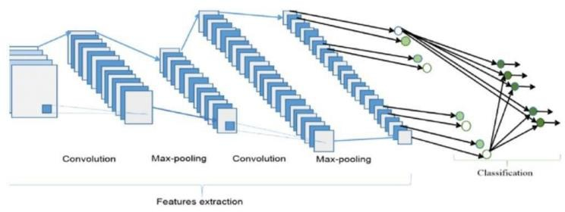
7.3 Convolution Neural Network layers
Figure 7.3.1 Convolutional Neural Network Layers

7.3.2 Convolution Layer
This layer involves scanning the entire image for patterns and plotting it in a 3x3 matrix. This image-related feature is known as the kernel matrix. Each Ernadros value is known as a weight vector.
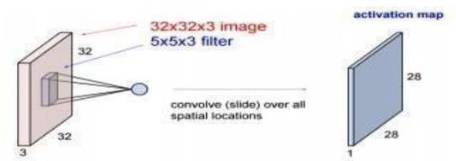
Figure 7.3.2.1 Convolutional Layer
7.3.3 Pooling Layer
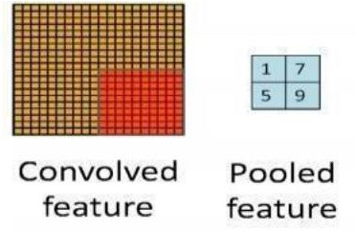
Here, after summarizing, the image matrix is divided into 4 non-overlapping rectangular segments. There are two types of pools, Max Pool and Average Pool. The maximum pool represents the highest value in the corresponding matrix area. The average pool represents the average value in the corresponding matrix area. The main advantage of the pool layer is that it improves computer performance and reduces the possibility of overclocking.
Figure 7.3.3.1 Pooling Layer
7.3.4 Activation Layer
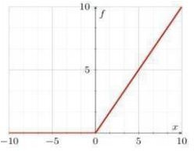
Entrainment is part of a convolutional neural network where the values are regular, i.e. distance. The convolution function used is ReLU, which only allows positive values and then rejects negative values. A function of low computing costs.
Figure 7.3.4.1 Graph of positive ReLU Func

Chapter 8
TESTING AND RESULT DISCUSSION
8.1 TESTING
Testing is the process of evaluating a system or its components to determine whether it meets specified requirements. Testing is the execution of the system against actual requirements to identify gaps, errors, or missing requirements. System test Software or hardware is tested on a complete and integrated system to assess compliance with specified system requirements. System testing falls within the scope of black-box testing and therefore does not require knowledge of the code's internal structure or logic. Typically, system testing takes as input all "integrated" software that passes integration testing, and the software system itself is integrated with applicable software systems. The purpose of integration testing is to detect conflicts between integrated software components. System testing is a more limited type of testing. It tries to find flaws in conventions and systems. System testing is performed on the entire system against the functional requirements specification (FRS) and/or system requirements specification (SRS). System testing not only tests the design, but also customer behavior and perceived expectations. It is also intended to test software/hardware requirements beyond the limits set in the specification. Before using techniques to design effective test cases, software engineers must understand the basic principles of software testing. All tests must be in accordance with customer requirements.

8.1.1 Types of testing
Software testing techniques are generally divided into two categories: white box testing and black box testing. These two approaches are used to describe the test engineer's approach to designing test cases.
a) White box testing (also known as source code testing, glass box testing, open box testing, and structural testing by looking at the source code) tests the internal structure or functionality of the program; end user white box. Testing uses an internal systems perspective as well as programming expertise to design test cases. The tester chooses inputs to use to pass through the code and determine the corresponding output. While white box testing can be applied to the unit, integration, and system levels of the software testing process, it is usually performed at the unit level. It can test paths within a unit, paths between units during integration, and paths between subsystems during system-level testing. Although this test design method can detect many errors or problems, it cannot miss ineffective parts or specification requirements.
b) Black Box Testing: The method of testing a program without knowing its inner workings is called black box testing. The tester is not familiar with the system architecture and does not have access to the source code. Typically, when performing black box testing, the tester will interact with the system's user interface by providing input and checking the results without knowing how and where the inputs are moved. The project is tested in various scenarios including unit testing, integration testing and system testing as described below.

8.1.2 Levels of Testing:

There are different levels during the exam. Test levels include different methods that can be used to test software. The main levels of software testing are:
Functional Testing: This is a form of black box testing based on the specifications of the software to be tested. The program is tested by providing input and verifying that the output matches the intended functionality. Software functional testing is performed on a complete and integrated system to assess compliance with specified system requirements. There are five steps to check the app's functionality.
• Define the intended function of the program.
• Generate test data based on application specifications.
• Output based on test data and operational characteristics.
• Writing test scripts and executing test cases.
• Compare actual and expected results based on executed tests.
Non-functional Testing: This section is based on testing the application from its non-functional features. Non-functional testing is software testing that is not functional in nature, but is designed to test performance, security, user interface, etc. including testing from requirements such as

Unit Testing:
Unit testing is a method in which the source code, control data, operating procedures, and associated operating procedures of one or more computer program modules are tested to determine whether they are suitable for use. Literally, a unit can be seen as the smallest test piece of a program. All syntax errors etc. take root during the growth process. For this designed test, each instruction in the program or module is executed, that is, each path in the program is null. Test cases are randomly selected data to test possible branches after all cycles.

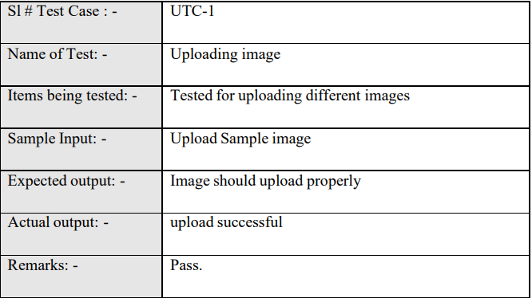
8.1.2.1 Unit Testing Test Case 1
Table 8.1.2.1 Unit Testing Test Case 1

S1 # Test Case: | UTC-2
Name of Test | Detecting cancer images
Items being tested | Test for different cancer images
Sample Input | Tested for different images of cancer
Expected output | Different types of cancer should be displayed
Actual output | Should Display disease or Healthy
Remarks | Predicted result

8.1.2.2 Unit Testing Test Case 2
Table 8.1.2.2 Unit Testing Test Case 2

Integration testing:

Integration testing is a level of software testing where individual components are combined and tested as a group. The purpose of this level of testing is to identify defects in the interaction between integrated units. Test drives and test stubs are used to help test the integration. Integration testing is defined as testing the integrated part of an application to determine whether it functions correctly. It is after the tenure exam and before the confirmation exam. Integration testing can be done in two ways: bottom-up integration testing and top-down integration testing.
1.Bottom-up integration: This test starts with unit testing and then testing high-level combinations of components called modules or structures.
2. Top-down integration: In this test, the high-level module is tested first and the low-level module is tested later. In an open source software development environment, bottom-up testing is usually tested first. This process is complemented by several full program tests, preferably in scenarios similar to real-world conditions.

8.1.2.3 Functional Testing Test Case 1
S1 # Test Case: | ITC
Name of Test | Working of choose file option
Items being tested | User convenience to access images stored
Sample Input | Click and select the image
Expected output | Should open selected Image
Actual output | Selected open selected image
Remarks | Pass.
Table 8.1.2.3 Functional Testing Test Case 1
8.1.2.4 Functional Testing Test Case 2
S1 # Test Case: | ITC-2
Name of Test | Working of Segmentation and Displaying different cancer image
Items being tested | Selecting different images and verifying cancer images
Sample Input | Click and select the image
Expected output | Should show x-ray or ct scan images predict disease or healthy
Actual output | Image Segmented, cancer detected should be displayed
Remarks | Pass.
Table 8.1.2.4 Functional Testing Test Case 2

System Testing:

System test Software or hardware is tested on a complete and integrated system to assess compliance with specified system requirements. System testing falls within the scope of black-box testing and therefore does not require knowledge of the code's internal structure or logic. System testing is important for the following reasons:
• System testing is the first step in the software development life cycle where the application is tested.
• Applications are thoroughly tested to ensure they meet functional and technical specifications.
• This application is tested in an environment very close to the production environment where it will be deployed.
• System testing allows you to verify, verify and validate business requirements as well as application architecture.
8.1.2.5 System Testing is shown in the below table
S1 # Test Case: | STC-1
Name of Test | System testing in various versions of OS
Items being tested | OS compatibility.
Sample Input | Execute the program in windows XP/Windows-10
Expected output | Performance is better in windows-10
Actual output | Same as expected output,performance is better in windows-10
Remarks | Pass.
Table 8.1.2.5 System Testing is shown in the below table

8.2 RESULTS
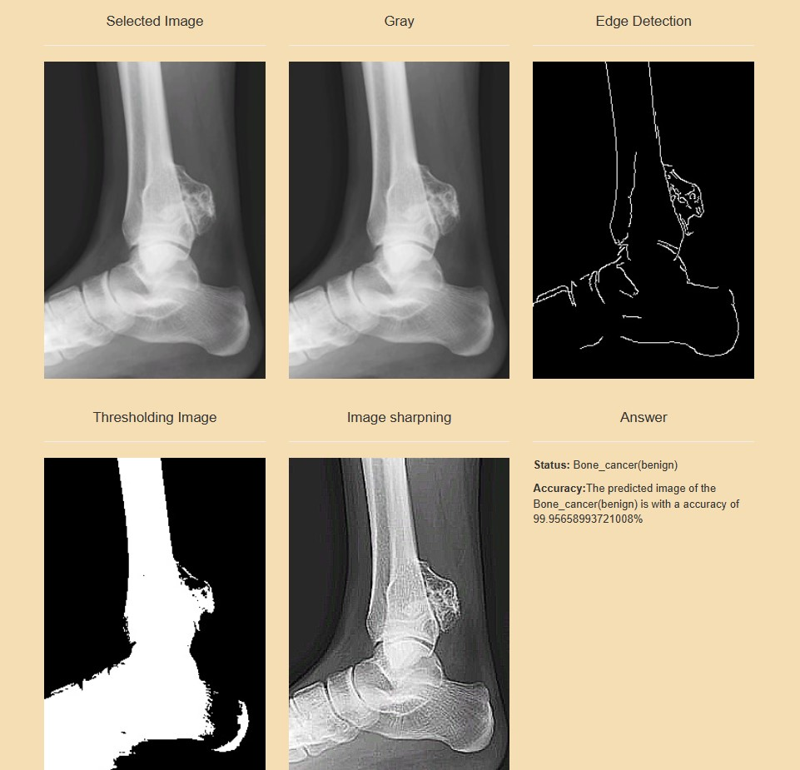
Figure 8.2.1 Bone Cancer (Benign)
1. Bone cancer, when described as benign, means that the tumor in question is non-cancerous or non-malignant.
2. Benign bone tumors originate in bone or cartilage cells and typically do not spread to other parts of the body.
3. These tumors are usually slow-growing and localized, posing less risk than malignant tumors.
4. Some common types of benign bone tumors include osteochondromas, osteoid osteomas, enchondromas, and nonossifying fibromas.

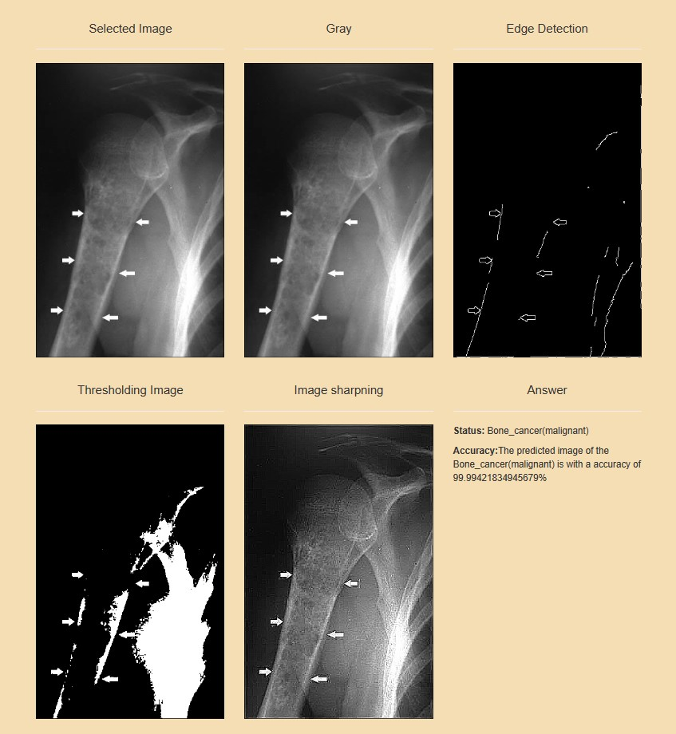
Figure 8.2.2 Bone Cancer (Malignant)
1. Malignant bone cancer refers to the presence of cancerous cells in the bone tissue, which can rapidly grow and spread to other parts of the body, a process known as metastasis.
2. Malignant bone tumors can cause symptoms such as persistent bone pain, swelling, fractures, and unexplained weight loss.
3. Diagnosis usually involves imaging tests such as X-rays, CT scans, or MRIs, as well as biopsy to examine the tissue under a microscope.
4. Treatment for malignant bone cancer often involves a combination of surgery, chemotherapy, and radiation therapy.
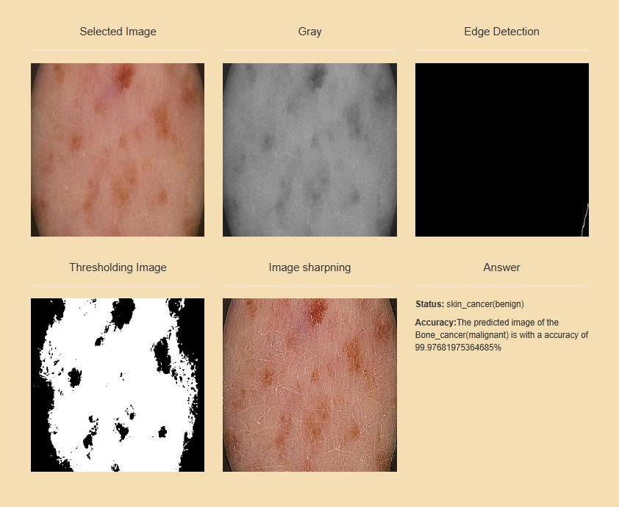
Figure 8.2.3 Skin Cancer (Benign)

1. Benign skin cancer refers to non-cancerous growths or lesions that develop on the skin.
2. Unlike malignant skin cancers, such as melanoma, benign skin cancers do not invade nearby tissues or spread to other parts of the body.
3. While benign skin tumors are generally harmless, it's important to monitor them for any changes in size, color, or shape.
4. If you notice any suspicious changes or if a lesion becomes symptomatic, it's advisable to consult a dermatologist for further evaluation and appropriate management.
5. In some cases, a biopsy may be necessary to confirm the diagnosis and rule out the possibility of malignant skin cancer.

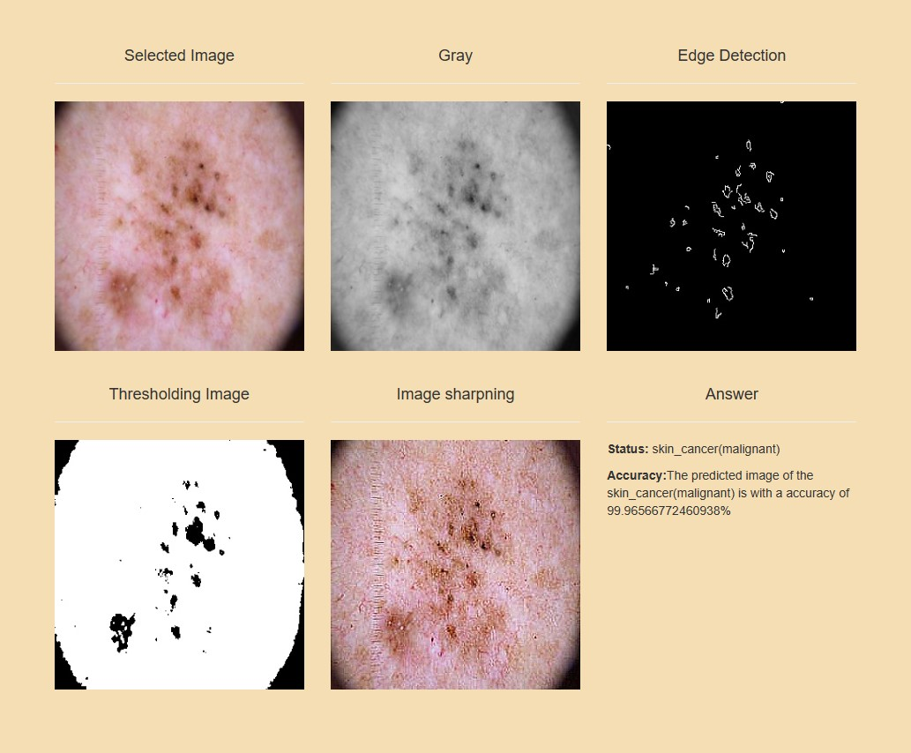
Figure 8.2.4 Skin Cancer (Malignant)
1. Malignant skin cancer refers to cancerous growths or lesions that develop on the skin. Unlike benign skin tumors, malignant skin cancers have the potential to invade nearby tissues and spread (metastasize) to other parts of the body, posing a serious health risk if left untreated.
2. Early detection and treatment are crucial for improving outcomes in malignant skin cancer.
3. Treatment options may include surgical excision, Mohs surgery (a specialized technique for removing skin cancer layer by layer), radiation therapy, chemotherapy, targeted therapy, and immunotherapy, depending on the type and stage of cancer.
4. Additionally, regular skin examinations and sun protection measures are essential for preventing the development of skin cancer and detecting it at an early, more treatable stage.
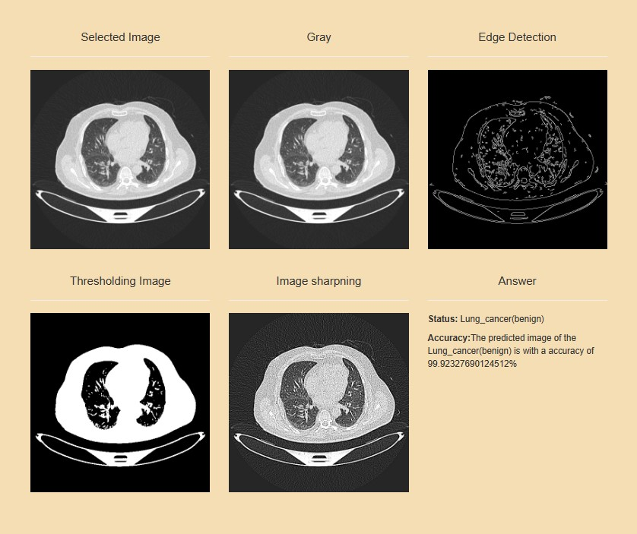
Figure 8.2.5 Lung Cancer (Benign)
1. Lung cancer is primarily known for being malignant, meaning it involves cancerous growths that have the potential to spread to other parts of the body. However, benign lung tumors can also occur, although they are relatively rare compared to malignant lung tumors.
2. Benign lung tumors are non-cancerous growths that develop in the lung tissue. They can originate from various types of cells in the lungs, including the epithelial cells lining the airways, the supportive connective tissue, or even blood vessels.
3. Benign lung tumors usually do not cause symptoms unless they grow large enough to compress nearby structures or obstruct the airways.
4. They are often discovered incidentally on imaging studies such as chest X-rays or CT scans performed for other medical reasons.

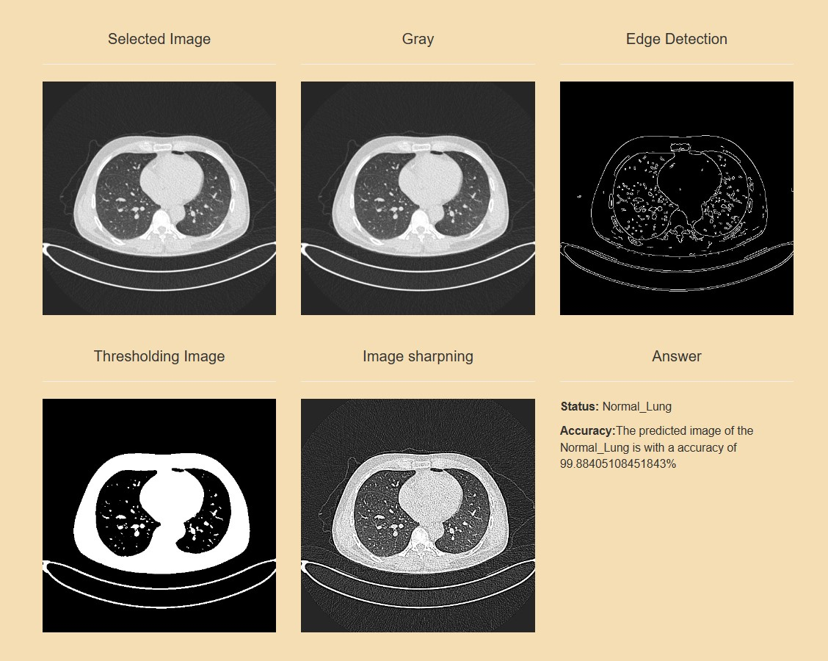
Figure 8.2.6 Lung Cancer (Normal)
1. "Normal" lung tissue refers to healthy, non-cancerous tissue that makes up the structure and function of the lungs.
2. Lung cancer, on the other hand, involves the abnormal growth of cells within the lung tissue, which can be malignant (cancerous) or, more rarely, benign (non-cancerous).
3. Benign lung tumors are much less common and generally do not pose a serious health risk. They can include various types of non-cancerous growths, such as pulmonary hamartomas, adenomas, or papillomas, among others.
4. Diagnosis of lung cancer, whether malignant or benign, typically involves imaging studies such as chest X-rays, CT scans, or PET scans, as well as tissue biopsy for definitive diagnosis.

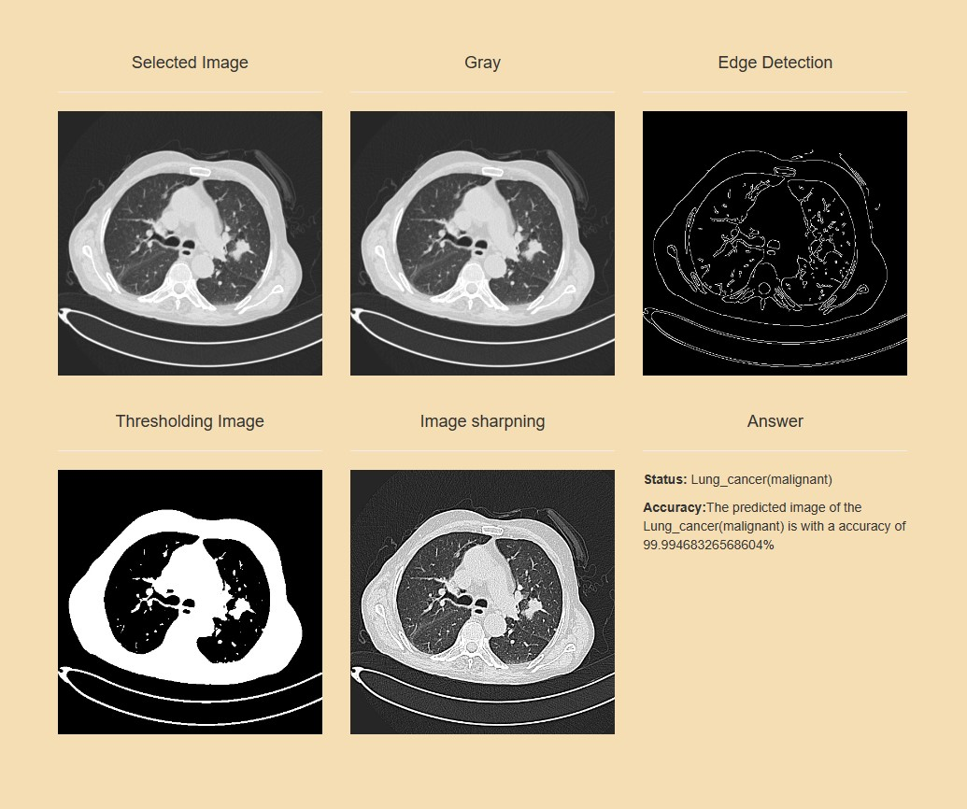
Figure 8.2.7 Lung Cancer (Malignant)
1. Malignant lung cancer refers to the abnormal growth of cells in the lungs that have the potential to invade nearby tissues and spread to other parts of the body.
2. It is one of the leading causes of cancer-related deaths worldwide, primarily because it is often diagnosed at an advanced stage when it has already spread beyond the lungs.
3. Malignant lung cancer often presents with symptoms such as persistent cough, chest pain, shortness of breath, wheezing, coughing up blood, fatigue, unexplained weight loss, and recurrent respiratory infections.
4. However, early-stage lung cancer may not cause noticeable symptoms, which can contribute to delayed diagnosis and poorer outcomes.

Chapter 9
CONCLUSION
The application of deep learning in multiple cancer detection holds immense promise for revolutionizing early diagnosis and treatment strategies. Through the analysis of diverse datasets and the extraction of intricate patterns, deep learning models offer unprecedented accuracy and efficiency in identifying various types of cancer. This innovative approach not only enhances diagnostic accuracy but also paves the way for personalized medicine, ultimately improving patient outcomes and survival rates. However, further research and validation are imperative to ensure the reliability and generalizability of these models across different populations and healthcare settings. By harnessing the power of deep learning, we can advance towards a future where timely cancer detection becomes a reality, fostering better healthcare delivery and saving countless lives.

Chapter 10
REFERENCES

1. Lung Cancer Classification and Prediction Using Machine Learning and Image Processing by Sharmila Nageswaran, G. Arunkumar, Anil Kumar Bisht, Shivlal Mewada, J. N. V. R. Swarup Kumar, Malik Jawarneh, and Evans Asenso https://doi.org/10.1155/2022/1755460
2. Computational Technique Based on Machine Learning and Image Processing for Medical Image Analysis of Breast Cancer Diagnosis by V. Durga Prasad Jasti , Abu Sarwar Zamani, K. Arumugam, Mohd Naved, Harikumar Pallathadka, F. Sammy, Abhishek Raghuvanshi, and Karthikeyan Kaliyaperumal https://doi.org/10.1155/2022/1918379
3. Prediction of Breast Cancer, Comparative Review of Machine Learning Techniques, and Their Analysis by NOREEN FATIMA 1 , LI LIU 1 , SHA HONG1 , AND HAROON AHMED
https://doi: 10.1007/s41870-020- 00427-7
4. Bone cancer detection using machine learning techniques by Deepshikha Shrivastava1 , Sugata Sanyal2 , Arnab Kumar Maji1 and Debdatta Kandar https://www.sciencedirect.com/science/article/pii/B9780128179130000171

PUBLICATIONS
GITHUB LINK:
https://github.com/rahulalmelkar/cancer-detection-cnn
RESEARCH PAPER LINK:
https://ijarcce.com/papers/healthcare-application-for-cancer-detection-and-analysis-using-machine-learning-and-image-processing/
CERTIFICATES:
https://drive.google.com/drive/folders/1GwlMUqZ8oyH0zTULtQ9wZi-9NncwwD_Y

